Different Types of Data
In the context of machine learning and data science, different types of data refer to the structure and characteristics of the data that can be analyzed:
- Structured Data: Data that is organized in a defined manner, typically in tabular form with rows and columns.
Data that is organized in a defined manner, typically in tabular form with rows and columns.
Examples: Databases, Excel spreadsheets, CSV files
Usage: Structured data is easy to input, store, and query, making it suitable for traditional machine learning algorithms.
- Unstructured Data: Data that doesn’t have a predefined structure and is often text-heavy.
Examples: Text documents, images, videos, audio files.
Usage: Requires more preprocessing and specialized techniques like natural language processing (NLP) or computer vision for analysis.
- Semi-structured Data: Data that does not confirm to a fixed schema but contains tags or markers to separate elements.
Examples: JSON, XML files, HTML documents.
Usage: Semi-structured data is more flexible than structured data and often used in web applications and APIs.

Data Science Mining Methodologies:
CRISP-DM, KDD and SEMMA are commonly used for data mining and knowledge discovery.

Knowledge discovery in databases (KDD): A methodology defined by a sequence of steps. Iteration and looping back to previous steps in the process are possible with KDD.
1.Selection: The selection of data from a large data set.
2.Pre-Processing: This stage consists of the target data where cleaning and pre-processing is done, to get consistent data.
3.Transformation: Transform the data into a read for analysis.
4.Data Mining: This stage consists of applying algorithms and patterns to the data.
5.Evaluation: This stage consists of evaluation of mined patterns.
6.Knowledge: After the evaluation is completed, we will get the results.

Cross Industry Standard process for Data Mining (CRISP-DM):
1.Business Understanding: This is the initial phase focusing on selection of data set and understanding the requirements according to business point of view.
2.Data Understanding: Collecting the data and understanding that data.
3.Data Preparation: It prepares the data for modeling, collecting, transformation and selection. It covers all the phases from initial raw data to final data set.
4.Modelling: In this phase, various modelling techniques are selected and applied, and their parameters are calibrated to optimal values.
5.Evaluation: At this stage the models are evaluated to get the results.
6.Deployment: Deploying the model in a production environment to get the application so that the customer can use it.
Advantages: Industry standard, Provide a structured approach to data mining.
hDisadvantages: Can be rigid, Time consuming.
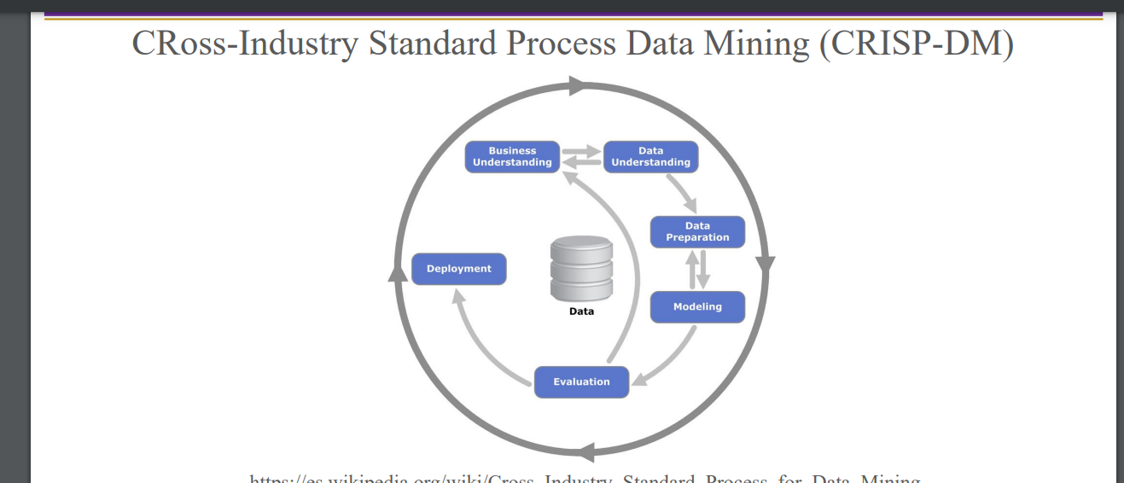

SEMMA: It is independent of data mining models and techniques.
1.Sample: This stage consists of sampling the data by extracting a large data set big enough to contain significant information.
2.Explore: This stage consists of exploration of data to gain understanding and ideas.
3.Modify: Modifying the data by creating, selecting and transforming.
4.Model: This stage consists of modeling the data, so that we can predict data output.
5.Assess: This stage consists of assessing the data by evaluating on how well it performs.
Machine Learning: Machine Learning is a important sub-discipline of AI. Machine learning is the science of enabling computers to learn from experience (data) and make decisions or predictions without being explicitly programmed for specific tasks.
Applications: Spam emails, NLP, Robotics, Finance, Navigation, Recommender Systems,
Use cases:
Computer Vision (CV), Natural Language Processing (NLP) such as machine translation (MT), semantic search, text-to-speech, virtual assistants and chatbots, automatic speech recognition (ASR)
- MT solutions −→ Google Translate and AutoML, Fairseq (Facebook), Amazon Sockeye, Alibaba, DeepL, Baidu, IBM, Microsoft’s Bing Translator, etc.
- Voice Assistant −→ Alexa, Google Assistant, Siri, Microsoft Cortana, Samsung Bixby.

ML algorithm Can be divided into Four Types:
Supervised Learning Algorithm: The model is trained on the labelled data for desired output. It maps input to get the correct output.
Use case: Image recognition, Email filtering (Recognizing spam emails).
It can be sub-divided into either classification or regression algorithms.
Classification: Classification is the task of predicting a discrete label or category from input data.
- Examples:
  - Email spam detection (spam vs. not spam)
  - Handwritten digit recognition (0–9)
  - Disease diagnosis (e.g., healthy vs. diabetic)

Regression: Regression is the task of predicting a continuous numerical value from input data.

Examples:
- Predicting house prices based on features like size and location
- Forecasting stock prices
- Estimating temperature for a given day

Unsupervised Learning: The model learns from the unlabelled data finding structures or patterns.

Common Techniques:
- Clustering – Groups similar data (e.g., customer segmentation).
- Dimensionality Reduction – Reduces data complexity (e.g., PCA).

Examples:
- Market segmentation
- Anomaly detection
- Topic modeling from text

Semi-Supervised Learning: It is a combination of both supervised and Unsupervised learning algorithms. The model is trained on a small amount of labeled data and a large amount of unlabeled data.

Examples: Medical image classification with few annotated scans, Speech recognition.

Reinforcement Learning: The model learns by interacting with an environment, receiving rewards or penalties based on its actions.

Examples: Game playing, Robotics navigation.

Google Teachable machine: It is a Fast way to classify photos using cloud platform with binary or multi-class classification. It Allow you to work with audio classification and also works for live-pose detection.

Predictive Model Interchange Format:

Pickle: It converts a Python object to a bitstream and allows it to be stored to disk and reloaded on demand. It is Easy-to-use format to store ML models

ONNX (Open Neural Network Exchange Format): An open format that supports the storing and porting of predictive models across libraries and languages. Most deep learning libraries support it (e.g. scikit-learn)

PMML (Predictive model markup language): PMML – an XML-based predictive model interchange format.Like ONNX, it is also an interchange format for predictive models. Scikit-learn libraries offer conversion of the ML models to PMML format

PFA (Portable Format for Analytics): It is a JSON-based predictive model interchange format. As above, a PFA-enabled host running on the cluster can execute a ML model in a controlled way

OpenStack Meteos: OpenStack is a free open standard cloud computing platform. Meteos is named from Meteo (Meteorologist) + OS (OpenStack). Meteos is a new Project which provides Machine Learning as a Service (MLaaS) in OpenStack. Meteos allows users to analyze huge amount of data and predict any value by data mining and machine learning algorithms only by executing API. Meteos creates a workspace of Machine Learning via a Sahara spark plug in and manages some resources and jobs regarding Machine Learning.

Just give an overview of: Azure Machine Learning, Google Cloud Machine Learning Engine,

Amazon Sage Maker.

Cloud computing ML services: OpenStack Meteos, Microsoft Azure Machine Learning, Google Cloud ML Engine, Google Teachable ML, Amazon SageMaker (Autopilot)

E.g. Azure ML Matchbox Recommender Engine.
Outliers:
Outliers are data that differ significantly from other data in a sample Outliers
• Skew your data distributions
• Impact your basic statistical measures
• Can be responsible for the underperformance of certain algorithms.
The ML community is somewhat divided over the issue of outliers If it is apparent that outliers may occur due to errors in data collection/input or corrupted data, then it is reasonable to remove such outliers
In some cases, the outliers may be representative of a particular scenario
• If you are removing the outliers, then your model can no longer account for these instances If it can be determined that an outlier is in fact erroneous, then it should be deleted from the dataset (or alternatively clamped or corrected if possible)
How do you detect outliers:
When looking for outliers a good place to start is to look at every single variable by itself using a graphical inspection
• This is often referred to as univariate outlier detection We can easily create boxplots to help visualize outliers
• Either through Seaborn or Pandas You can spot the problematic variables by looking at the extremities of the distribution
Box Plot:
A box plot is a graphical representation of data that shows the distribution through quartiles. Outliers can be detected as points outside the "whiskers" of the plot (typically 1.5 times the interquartile range (IQR) from the quartiles).
How to Use: Plot a box plot for your dataset and look for points outside the whiskers.
A box plot is a visual tool that represents the distribution of data based on five summary statistics: minimum, Q1, median, Q3, and maximum. Outliers are shown as individual points outside the whiskers of the box plot.
Application: Provides a quick visual indication of outliers.

DBSCAN(Multi variety outlier detection) – Learn in another pdf

Handling Imbalance:
Confusion Matrix – Learn in another pdf

Random undersampling is a technique used to handle imbalanced datasets—when one class (often the negative or majority class) significantly outnumbers another (positive or minority class).

Random undersampling reduces the size of the majority class by randomly removing samples, so the dataset becomes more balanced.

Pros:
- Simple and fast
- Can improve model performance on the minority class (e.g., recall, F1-score)

Cons:
- Can lose valuable information by discarding data
- May cause underfitting if too much data is removed

Example:Suppose you have:
- 9000 samples of class 0
- 1000 samples of class 1

Random undersampling reduces class 0 to 1000 samples → both classes now have 1000 samples.

Random oversampling is a technique for addressing class imbalance by duplicating examples from the minority class to increase its representation in the dataset.

Adds copies of existing minority class samples until the number of samples equals (or approaches) that of the majority class.

Balances the class distribution without losing data from the majority class.

Pros:
- Simple to implement
- Retains all original data (unlike undersampling)
- Often improves recall and F1-score for the minority class

Cons:
- Risk of overfitting: duplicated data doesn't introduce new information
- Increases training time and memory usage

Example:

Original class distribution:
- Class 0: 9000 samples
- Class 1: 1000 samples

After random oversampling:
- Class 1 is increased to 9000 samples by duplicating existing data points

SMOTE (Synthetic Minority Over-sampling Technique) is a powerful technique for handling imbalanced datasets by generating synthetic samples for the minority class, rather than duplicating existing ones.

Pros
- Avoids overfitting caused by duplicating data
- Works well with models that are sensitive to class imbalance

Cons
- Can generate noisy or unrealistic samples if the data has many outliers
- Works only with numeric data (use encoding for categorical features).

Variants of SMOTE
- Borderline-SMOTE: Focuses on samples near decision boundaries
- SMOTE-NC: Supports categorical features (numeric + categorical)
- KMeans-SMOTE: Combines SMOTE with clustering for better sample diversity

Tomek Links are a data cleaning technique used to improve class separation in imbalanced datasets, typically in combination with undersampling.

A Tomek Link exists between two samples of different classes (say, one majority and one minority) if:
- They are each other’s nearest neighbors, and
- There is no other sample closer to either than they are to each other.

Pros
- Helps clean ambiguous or overlapping points near the class boundary
- Often used after oversampling (like SMOTE) to reduce overlap
- Reduces noise and improves class separability

Cons
- May remove useful borderline information if applied blindly
- Only helps if class boundaries are well-defined

Dimensionality reduction: It is the process of reducing the number of input variables (features) in a dataset while preserving as much relevant information as possible. It's used to simplify models, improve performance, and reduce overfitting or computational cost.

Why Use Dimensionality Reduction?
- Reduces model complexity
- Improves training speed
- Mitigates the "curse of dimensionality"
- Helps with data visualization
- Removes multicollinearity and noise

Common Dimensionality Reduction Techniques:

Principal Component Analysis (PCA) 🔬
- Projects data onto directions (principal components) that capture maximum variance
- Unsupervised
- Transforms features into uncorrelated components
- Often used for continuous numerical features

Linear Discriminant Analysis (LDA) :
- Like PCA but supervised (uses class labels)
- Maximizes class separability, not just variance

t-SNE (t-distributed Stochastic Neighbor Embedding) :
- Good for visualizing high-dimensional data in 2D or 3D
- Preserves local structure
- Non-linear and not for modeling, mainly for exploration

UMAP (Uniform Manifold Approximation and Projection) 🚀
- Like t-SNE but faster and better at preserving global structure
- Great for clustering and visualization tasks

Feature Selection vs. Feature Extraction
- Feature selection: Choose a subset of existing features (e.g., using mutual information, Lasso)
- Feature extraction: Create new features by combining existing ones (e.g., PCA, autoencoders)

